|  |
| --- |
| **STUDENT NAME** |
| Alley Chaggar |

**LAB #14**

BEFORE WE START 2

ACTIVITY 1 2

ACTIVITY 2 10

ACTIVITY 3 15

ACTIVITY 4 17

# BEFORE WE START

1. Double – click on the Blender icon on your desktop.
2. Close the tutorials windows.
3. Start rendering.

# ACTIVITY 1

## Character Rigging (Torso, Head, Arms)

A game character cannot move (animate) without a skeleton. A skeleton in animations is called a Rig and the process of assigning a rig to a character is called Rigging. This tutorial demonstrates how to rig a game character, adding an Armature.

Follow the steps below:

1. Open Blender and click on the Cube.
2. Click File 🡪 Open and locate the kid.blend project.
3. Click on the background images and delete them.
4. Click on the Scene Panel (side properties) and make sure that the Unit System is the Metric and the Unit scale is 1.0.
5. Scale the character if needed, to match the size of a young boy or girl (use the Measure tool).
6. Under the Object mode, click on the Add 🡪 Armature.
7. Position the new armature as shown below:  
     
   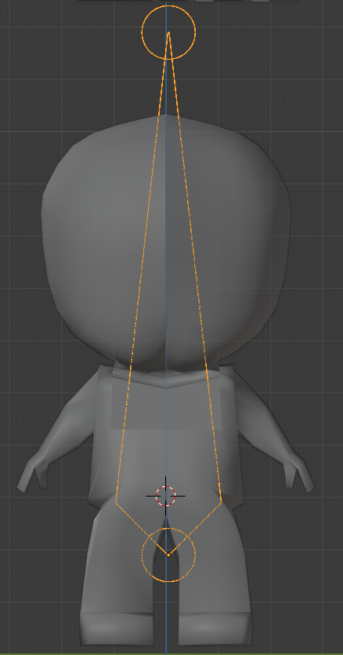
8. Make sure, you are working in X-Ray and Solid Mode (or Wireframe).
9. Switch to Edit Mode.
10. Select the Head of the Armature.
11. Press E or click on the Extrude tool and create a new bones up to the chest.
12. Extrude again with a new bone up to the base of the neck.
13. Extrude again with a new bone up to the top of the neck.
14. The result should be something like this.  
      
    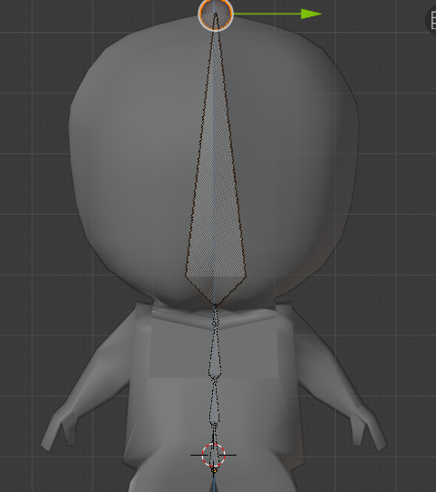
15. Turn to the Y axis.
16. Select the connection of the rig and move it to form a human like spine cord, as shown below:  
      
    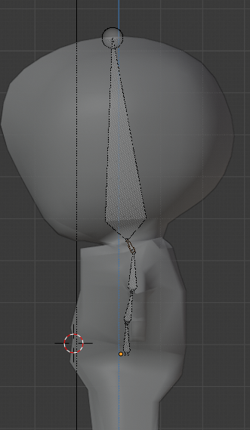
17. Select the Neck bone and press Shift+D.
18. Place it next to the shoulder as shown below (scale if needed):  
      
    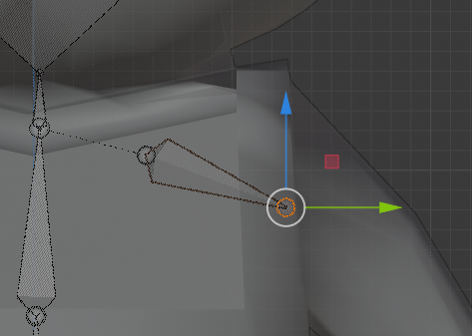
19. Extrude up to the elbow, then up to the base of the arm and then form a hand with fingers composed by two extrudes.
20. Turn to the side view (Y axis) and move to match the body.
21. Select the bones, just before the last extension and press Shift + D.
22. Move the finger to match the thumb and create something such as this:  
      
    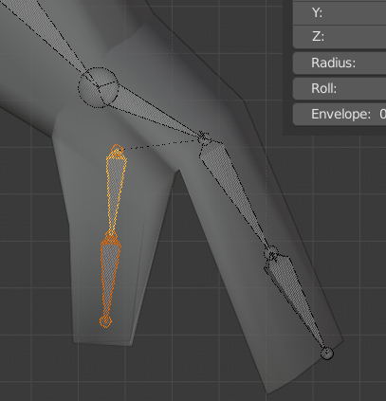
23. Right – click on the thumb bone and select Subdivide.
24. Move the two new bones to match the shape of the thumb.

Once you complete the previous steps:

|  |
| --- |
| **TASK 1.1:**  Take a screenshot of the models and paste it below: |
|  |

1. Click on the second from the bottom spine bone.
2. Press Ctrl+D.
3. Move the duplicated bone to the same height and right of the bottom spine bone.
4. Click on its head and move the head upside down, forming a big bone, as shown below:  
     
   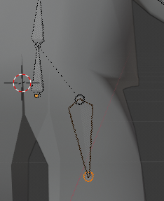
5. Enlarge as needed.
6. Extrude the new bone forming the second bone after the knee area.
7. Switch to the Y axis and fix the position of the bones.
8. Extrude the last bone and form a pelvis, such as shown below:  
     
   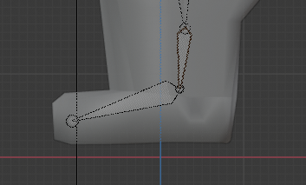

# ACTIVITY 2

## POSE MODE, NAMING THE BONES, IK

The Pose Mode allows us to move the skeleton as a whole and not as individual bones.

Follow the steps below:

1. Press A.
2. Press Shift + N.
3. Select View Axis.
4. Select the Pose Mode from the mode selection menu.
5. Move the Wrist bones and verify that everything moves as it supposes to.
6. Move the Hip bones and verify that everything moves as it supposes to.
7. Switch to Edit Mode.
8. Click and select the upper foot bones.
9. Right – click and select Parent 🡪 Clear.
10. Select the upper foot bone, hold Shift and select Parent 🡪 Make.
11. At the next menu select Keep Offset.
12. Click on the Hip bone (last spine bones) and click on the bone icon to the properties panel (right side).
13. Under the Bone tab change the name to Hips.  
      
    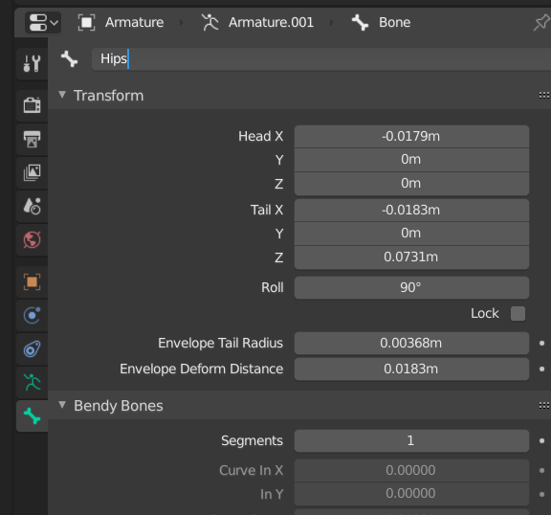
14. Select the bone above the Hips and name it Spine, then next name it Chest, the next Neck, the next Head.
15. Switch to the shoulder bone and name it Shoulder.L, UpperArm.L, LowerArm.L, Hand.L, Fingers01.L, Fingers02.L and Thumb01.L, Thumb02.L.
16. Select the Ankle of the foot tail of the bone, as shown below:  
      
    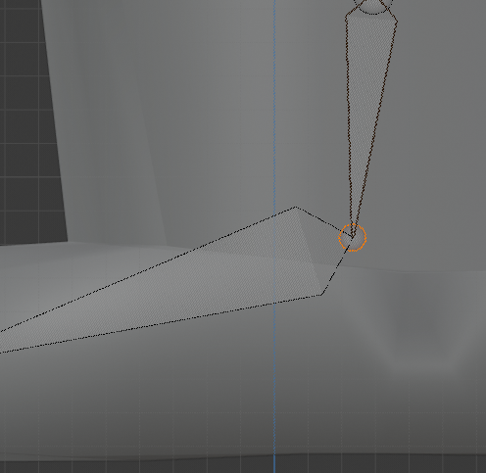
17. Press E and extrude.
18. Right click on the new bone and select Parent 🡪 Clear.
19. Select Clear Parent.
20. Click on the Root of the bone in the ankle and press Ctrl+D, creating a new bone and position it, as shown below:  
      
    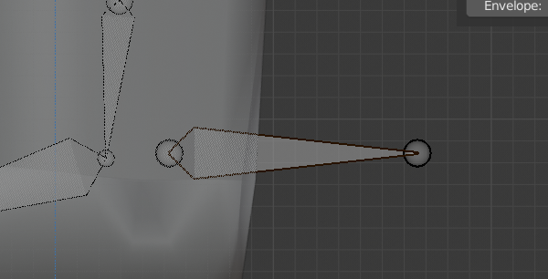
21. Name the new bone **IKBone**.
22. Click on the Cursor tool from the toolbar.
23. Click in front of the knee of the character.
24. Press Shift+A (a new bone should magically appear).
25. Scale the bone and place it as shown below:  
      
    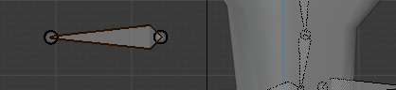
26. Name the new bone **PoleTarget**.
27. Turn to the Front View and move the bones in front of the knee.
28. Click on both new bones (one by one) and under the Properties, under the Bones tab scroll down and deselect the Deform option.
29. Switch to Pose Mode.
30. Select the IKBone, press Shift and select the Tibia bone.
31. Press Ctrl+Shift+C and select Inverse Kinematics.
32. (The Tibia bones should turn orangish, but to verify the change click on the Bone Constraints tab and check the Bone Constraints options.
33. Set the settings as shown below:  
      
    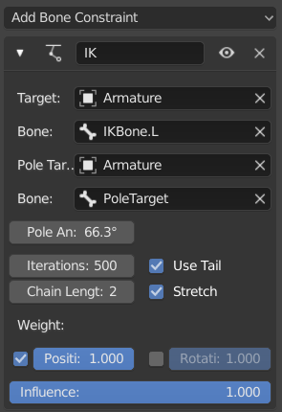
34. Set the Pole angle to a proper angle (around 60 to 90 degrees, but it mays vary).
35. If the Armature in the Pose mode looks messy, then turn to Edit Mode and move the joints, until you achieve a good outcome (you should need to switch modes a few times).
36. Make sure that all the leg moves, when you move the IKBone.L, as shown below:  
      
    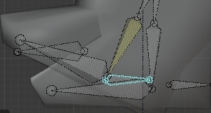
37. Click on the Foot bone (lower foot bone).
38. Click on the Bone Properties and expand the Relations tab.
39. Deselect the Inherit Rotation option.
40. Click on the IKBone, press Shift and select the Foot Bone.
41. Press Shift+Ctrl+C and select Copy Rotation.
42. Click on the Bone Constraints Options.
43. Set the World Space to Local Space in both properties.
44. Click on the Bone Constraints tab under the Properties.
45. Click Add Bone Constraint 🡪 Copy Constraint.
46. Set the options as shown below:  
      
    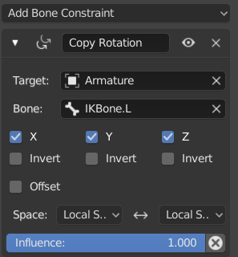
47. Select all the Invert options.
48. Check the movement by rotating the IKBone.

# ACTIVITY 3

## DUPLICATING AND MIRRORING, WEIGHTING

This tutorial demonstrates, how to create the right side of the rig, with only a few steps and how to add Weight. Weighting is the process that binds the Rig to the Mesh. After the completion of this tutorial, you should have a complete skeleton, that control the whole model.

Follow the steps below:

1. Select the Arm and the Legs and set the Cursor point at the center and bottom of the character, as shown below:  
     
   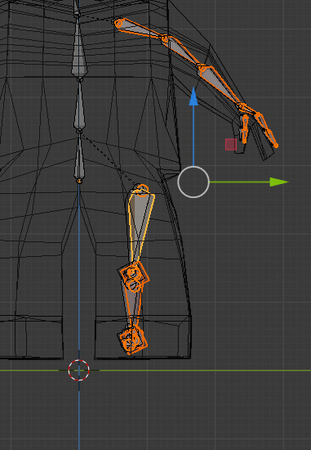
2. Press Shift+D and right-click (for preventing the movement).
3. Make sure the Cursor is placed at the center and bottom of the character.
4. Press Ctrl+M, to mirror the bones and then press Y (or the axis name you want to mirror the bones.
5. Move the bones if needed.  
   Select Armature 🡪 Names 🡪 Flip Names.
6. Switch to Pose Mode and change the names of the Bones to Shoulder.R, etc.
7. Switch to Object Mode.
8. Select the Mesh.
9. Click on the Modifiers tab and then click Add Modifier.
10. Select the Armature Modifier.
11. In the Object field select the **Armature**.
12. Select first the Character mesh and the pressing Shift the Armature.
13. Press Ctrl+P.
14. Select With Automatic Weights.
15. Select the bone at the base of the spine and rotate it left, right, front and back.

|  |
| --- |
| **TASK 3.1:**  What did happen? Answer the questions in the cell below. |
| Every bone moves with the spine bone. |

1. Select the object 🡪 Object 🡪 Set Origin 🡪 Origin to Center of Mass (Volume).
2. Scale the character to a weight of 1.0m.
3. Select the Armature (your character).
4. Click File Save as…
5. Save as KidBones.
6. Click File 🡪 Export 🡪 FBX…
7. Select the Selected Objects option.
8. Name the new object Kid.fbx.
9. Press Export FBX.

|  |
| --- |
| **TASK 3.2:**  Export the file and add it to the submission folder. |
| upload iconIn the LMS, add the file to the assignment Lab #14 submission folder. You can submit multiple files at a time. |

# ACTIVITY 4

## IMPORTING TO UNITY

This tutorial demonstrates how to import your model to Unity and setup the appropriate option. Then, this tutorial demonstrates the development of a simple character with a Character controller script.

Follow the steps below:

1. Open the Unity Hub.
2. Add a new 3D Project.
3. Name the Project, 3DCharacterRigged.
4. Under the Project tab, right – click 🡪 New 🡪 Folder.
5. Name the new folder Character.
6. In the Character folder, drag and drop the KidBones.blend or the KidBones.fbx file.
7. Click on the character.
8. Under the Inspector check the Model tab, if it looks like the image, below:  
     
   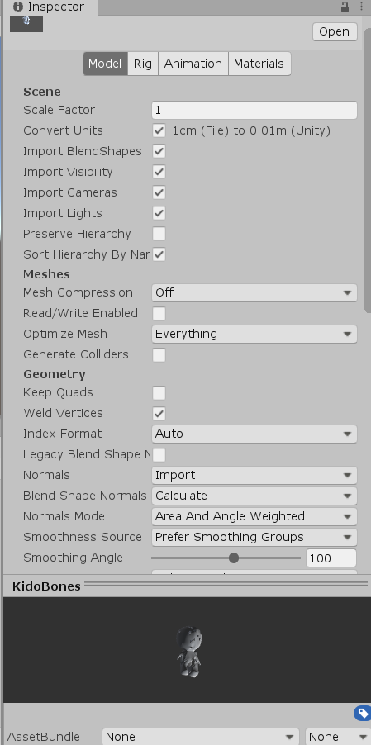
9. Click on the Rig tab.
10. Set the options as shown below:  
      
    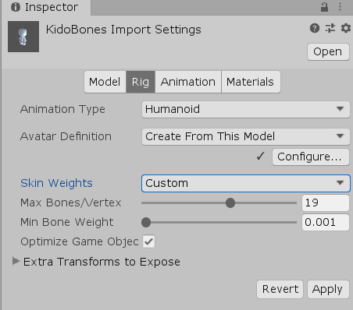
11. Click Apply.
12. Select the Materials tab.
13. Set the options as shown below:  
      
    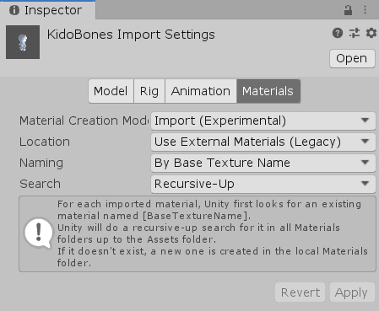
14. Click Apply.
15. Drag and drop the character in the Scene, view.
16. Click on the character and at the Inspector click the three little dots over the Transform tab, as shown below:  
      
    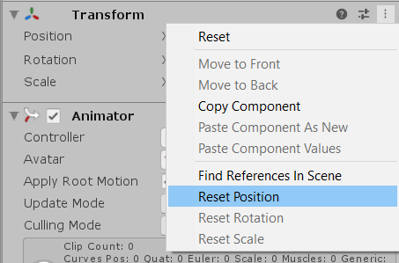
17. Click on the Reset Position.
18. Repeat the steps 16 – 17 for the camera.
19. Move and Rotate the camera to a Third – Person View.
20. Right – click under the Assets tab, under the Project.
21. Click Create 🡪 Folder.
22. Name the new folder, Scripts.
23. Right – click in the Scripts folder and select Create 🡪 Script.
24. Name the new Script, Player.
25. Open the script in VS.
26. Delete its content and copy the code from below:

|  |
| --- |
| **CODE** |
| using System.Collections;  using System.Collections.Generic;  using UnityEngine;  public class Player : MonoBehaviour  {  private string moveInputAxis = "Vertical";  private string turnInputAxis = "Horizontal";  public float rotationSpeed = 30.0f;  public float moveSpeed = 30.0f;  void Update()  {  float moveAxis = Input.GetAxis(moveInputAxis);  float turnAxis = Input.GetAxis(turnInputAxis);  ApplyInput(moveAxis, turnAxis);  }  private void ApplyInput(float moveInput, float turnInput)  {  Move(moveInput);  Turn(turnInput);  }  private void Move(float input)  {  transform.Translate(Vector3.forward * input * moveSpeed * Time.deltaTime);  }    private void Turn(float input)  {  transform.Rotate(0, input * rotationSpeed * Time.deltaTime, 0);  }  } |

1. Paste the code in the Player script.
2. Press Ctrl+S in VS.
3. Return to the Unity Editor.
4. Press Play.
5. Change the Move and Rotation speed as needed.
6. Click on the character under the Inspector click Add Component.
7. Add a Rigidbody component.
8. In the Rigidbody, set the Mass to 3 and the Drag to 8.
9. Under the Constraints freeze the Position to X and the Rotation to Y.
10. Click Add component and add a Capsule Collider.
11. Set the size of the collider, clicking on the Edit Collider button, so that it covers all the character.

|  |
| --- |
| **TASK 4.1:**  Compress and add it to the submission folder. |
| upload iconIn the LMS, add the file to the assignment Lab #14 submission folder. You can submit multiple files at a time. |

|  |
| --- |
| ADVANCED Create a Game Character with Wings and Claws. Create Facial characteristics and improve all its other parts. Create 3 additional assets in Blender (a Throne, a Reptile and a Crown). Import all the assets to Unity and create a very simple game level, with full interaction, physics, colliders and player controls. No Animation is needed. |

FINAL STEP: Save this document as a PDF. Upload the PDF to the Lab #14 submission folder.